Using methods described in this lesson (and you can also use some references), write a program which produces 32 child processes. Using the command pstree, to display a tree of these processes.

#include <stdio.h>
#include <unistd.h>
#include <stdlib.h>
#include <sys/wait.h>

int main() {

int i;

for (i = 0; i < 32; i++) {
int pid = fork();
if (pid < 0) {
exit(1);
}
else if (pid > 0) {
/* parent process */
}
else {
/* child process */
sleep(60);
exit(0);
}
}

for (i = 0; i < 32; i++) {
int status;
pid_t pid = wait(&status);
}

exit(0);

}

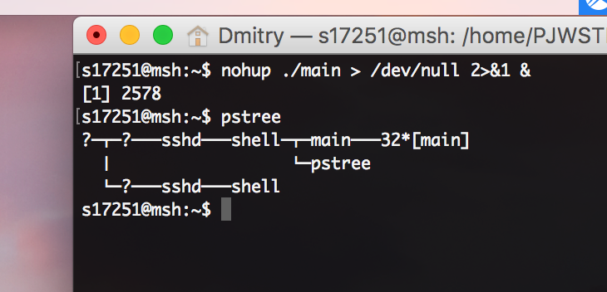

Explain the difference between the thread and the process.

While a process is an instance of some computer program, a thread is something created by that process. There can be multiple threads of a certain process that run concurrently.

Using the command ps, display all processes, along with information about threads. Describe what kind of information is presented in each column of your listing. Configure the ps command in such a way to obtain 11 columns or more.
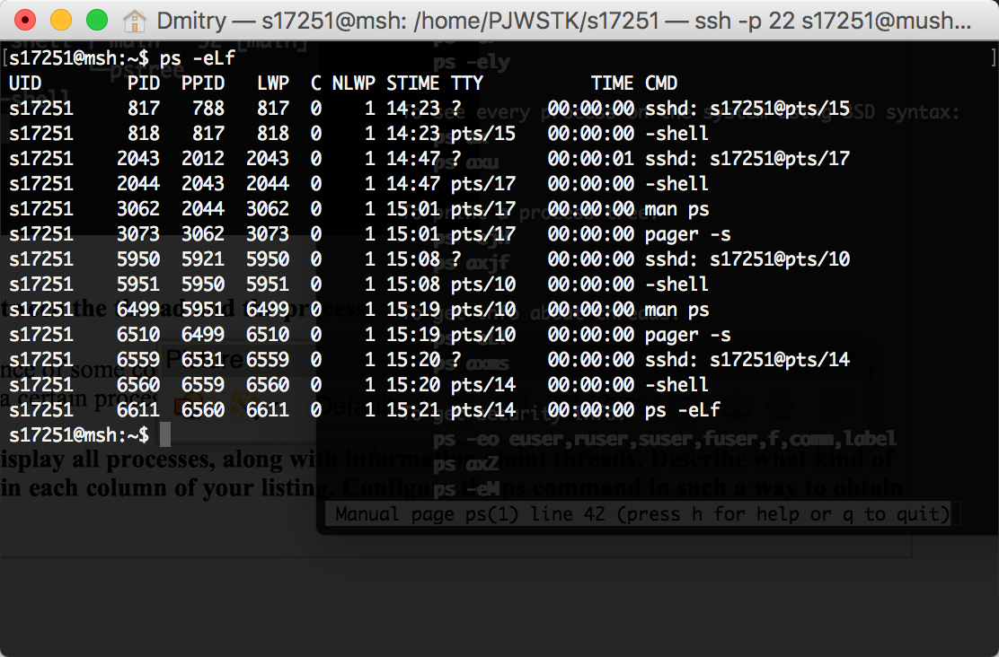
According to the man page of ps, ps -eLf prints info about threads.

Where

PID – process ID
PPID – parent process ID
LWP – thread ID

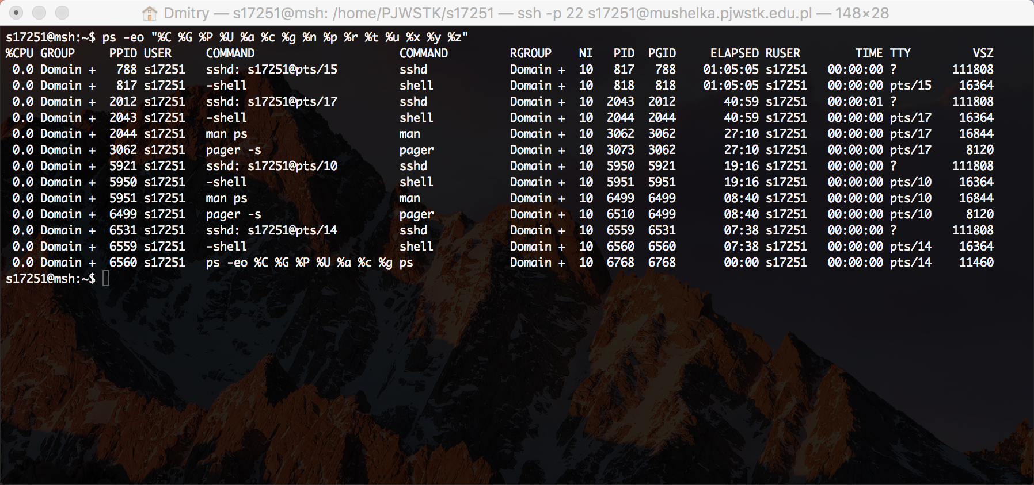

Log on to the computer mushelka.pjwstk.edu.pl and using the command pstree or ps display a tree of all processes from this computer. Find the PID of your shell and show me it on the screenshot. Find and shortly describe all other processes that you own. Let us return for a moment to the fourth part of our lesson and look at the tree of processes of the Unix system. Find four the most important processes on this figure. Answer, what they do and why some of them are not shown by ps command?

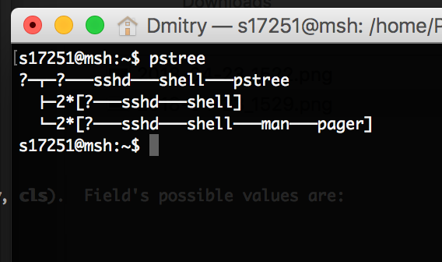
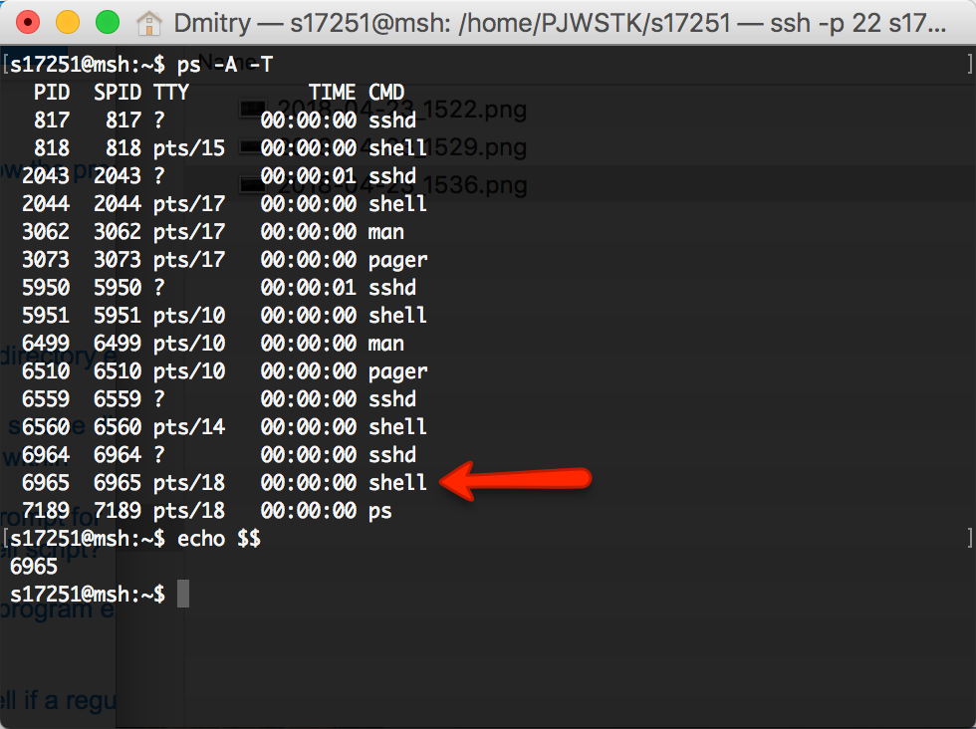
The arrow points at the current shell. The rest of the shells are the ones that I am running in parallel

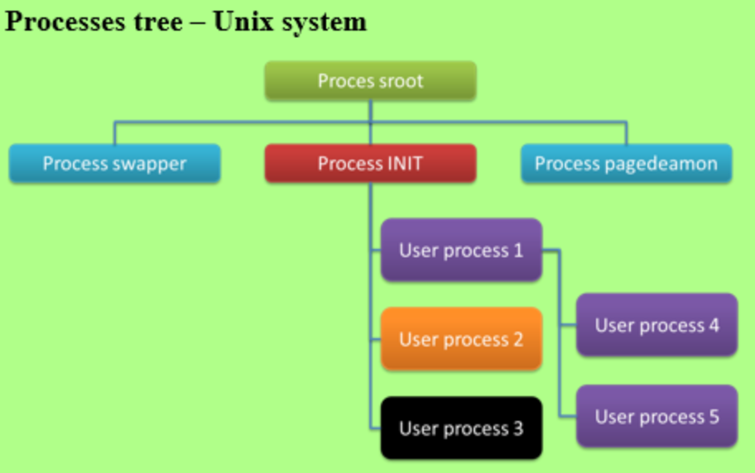
The lessons holds no information about sroot, INIT, swrapper or pagedeamon processes.

However, I guess the pagedeamon must be an environment delegated for running background processes created by the user. All four nodes at the top must be representing some system processes and therefore must be the most important ones.

